Student Result

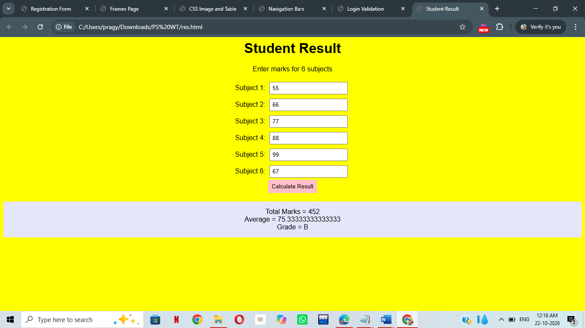

<html>
<head>
<title>Student Result</title>
<style>
body {
background-color: yellow;
text-align: center;
font-family: Arial;
}
input {
padding: 5px;
margin: 5px;
}
button {
padding: 8px;
background-color: pink;
border: none;
}
result {
background-color: lavender;
padding: 15px;
margin-top: 20px;}
</style>
</head>
<body>
<h1>Student Result</h1>
<p>Enter marks for 6 subjects</p>
Subject 1:
<input type="number" id="s1"><br>
Subject 2:
<input type="number" id="s2"><br>
Subject 3:
<input type="number" id="s3"><br>
Subject 4:
<input type="number" id="s4"><br>
Subject 5:
<input type="number" id="s5"><br>
Subject 6:
<input type="number" id="s6"><br>
<button onclick="calculate()">Calculate Result</button>
<div id="result"></div>
<script>
function calculate() {
var m1 = Number(document.getElementById("s1").value);
var m2 = Number(document.getElementById("s2").value);
var m3 = Number(document.getElementById("s3").value);
var m4 = Number(document.getElementById("s4").value);
var m5 = Number(document.getElementById("s5").value);
var m6 = Number(document.getElementById("s6").value);
var total = m1 + m2 + m3 + m4 + m5 + m6;
var average = total / 6;
var grade;
if (average >= 90) {
grade = "A+";
}
else if (average >= 80) {
grade = "A";
}
else if (average >= 70) {
grade = "B";
}
else if (average >= 60) {
grade = "C";
}
else if (average >= 50) {
grade = "D";
}
else {
grade = "F";
}
document.getElementById("result").innerHTML =
"Total Marks = " + total + "<br>" +
"Average = " + average + "<br>" +
"Grade = " + grade;
}
</script>
</body>
</html>

